Image | 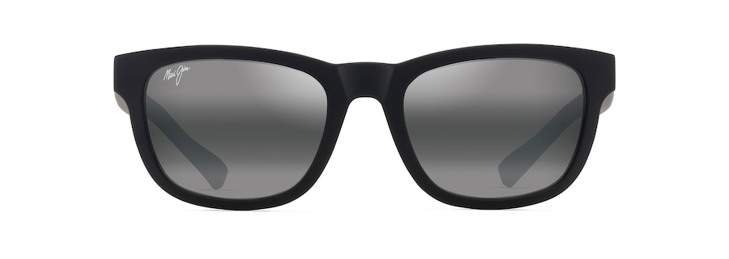
Brand | MAUI JIM
Model Name | KĀPI‘I
Price | RS 2899
PRODUCT DETAILS

